Daily Expenses

By

Harmandeep Singh

Level-6

Final Project

Table of Contents

Project Proposal 3

Goals and Objectives 3

Project Scope 3

Project Specifications 3

Target Audience 4

Project Deliverables 4

Resource Requirements 4

Project Tasks and Milestones 4

Project Assumptions 5

Project Report 5

Detail Design 6

Home Page 6

Registration Page 6

Login Page 7

Expense Records Admin View 7

User Accounts Admin View 8

Monthly Expense Reports Admin View 9

User Signup Page 9

Expense Records User View 10

Monthly Expense User View 11

Project Testing 11

User Manual 11

Summary 12

System Configuration 12

User Access Levels 12

# 

# Project Proposal

## Goals and Objectives

“Daily Expenses Report” project is an online web-based application designed to help the user to manage their daily expenses easily and effectively. In this web application there are two types of user’s admin and normal users. Admin can create, edit, delete, and check details of the expense’s records. Admin also has the right to edit, delete, and check details of the user accounts and monthly expense reports. Normal users can create, edit, delete, and access details of the expense records. Also, it can generate monthly expense reports, edit, delete, and access the details. New Users can signup for the application for free. The current user can manage their accounts. Admin can add new admins to the web application and can manage admin accounts.

## Project Scope

The scope of this project is to implement an app named “Daily Expenses Report” with the help of which users can manage their daily expenses and can generate monthly reports. The duration of the project is 20 working days which equals to 4 weeks.

## Project Specifications

* Admin login/logout
* Create, edit, delete, and check details of expense records by admin.
* Admin can delete, edit, and check details of the user accounts.
* Admin can edit, delete, and check details of the payments.
* Admin can register new admins.
* Users can login/logout.
* New users can register.
* Users and admin can manage their accounts.

## Target Audience

The target audience for this project is the people who would like to manage their day to day expenses. The age can go from 18 plus to 100 plus.

## Project Deliverables

The deliverables of the project are:

|  |  |
| --- | --- |
| **Deliverable** | **Description** |
| Final Report | This will be the final report of the project. |
| Coding | The executable code of the project will go under this. |
| Documentation | This portrays the documentation of the project. |
| Testing | All the test details will be covered in this part. |

## Resource Requirements

* Windows Operating System- 10.
* Microsoft word processor for documentation.
* Asp.net MVC Framework.
* 64-bit Processor and minimum 4 GB or more RAM.
* Identity framework- ASP.net.

## Project Tasks and Milestones

|  |  |  |  |  |
| --- | --- | --- | --- | --- |
| **Tasks** | **Week**  **1-2** | **Week**  **2-3** | **Week**  **3-4** | **Week**  **4-5** |
| Brainstorming and analysis |  |  |  |  |
| Planning and initial meeting Project Proposal document. |  |  |  |  |
| Database Design and UI Design |  |  |  |  |
| Identity framework implementation |  |  |  |  |
| Coding for admin and reporter |  |  |  |  |
| Testing |  |  |  |  |
| Final Documentation and closing |  |  |  |  |

## Project Assumptions

* One admin and user will be registered by default during the implementation of the project.
* Users will be available at every stage of implementation for feedback.
* The application will be available for free.

# Project Report

#### Functional and Non-Functional

|  |  |
| --- | --- |
| Users | Functional |
| Admin | * Login/logout. * Existing Admin can register new admins. * Admin can create, edit, delete, check details for expense records. * Admin can edit, delete, and check details for user accounts. * Admin can edit, delete, and check details for the monthly expense reports. * Can Manage their accounts. |
| User | * Can create, edit, delete, and check details for expense records. * Can generate monthly expenses reports * Can also edit, delete, and check details for monthly expense reports. * New users can sign up for free. * Login/Logout and account management. |
|  | Non- Functional |
|  | * High speed * Fast Loading time * High performance and security * All browsers and devices compatibility. |

## Detail Design

### Home Page

The main landing page of the application. On navigation bar options are- home, Expense Records, Monthly Expense Report, User Signup, Login and Register Admin User. A button named View Monthly reports is also present in the header images, which when click shows all the monthly reports available for the expenses.

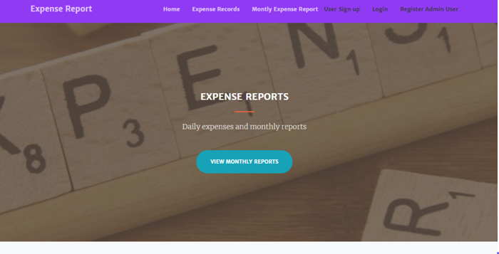

### Registration Page

With the help of this page, the admin can register new admins for the application.

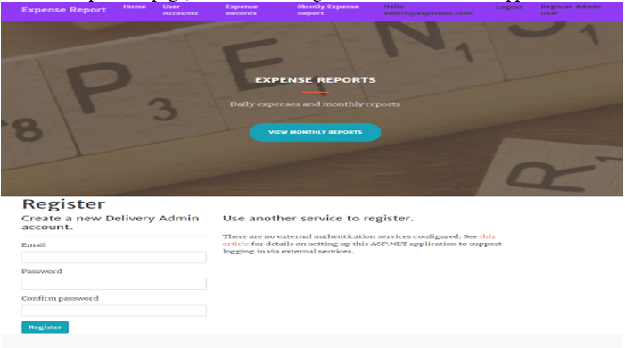

### Login Page

With the help of this page, user and admin can login to the application using their valid credentials. This Page is common to admin and user.

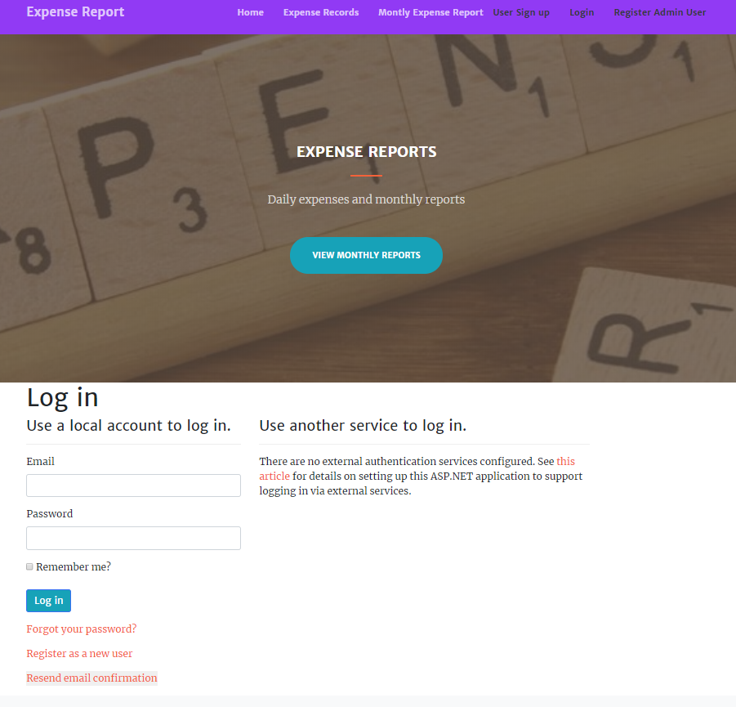

### Expense Records Admin View

This page highlights all the expense records on the application. Admin can create new expense records, edit, delete, and check details of the existing ones.

### User Accounts Admin View

With the help of this page admin can manage the user accounts by editing, deleting and checking their details.

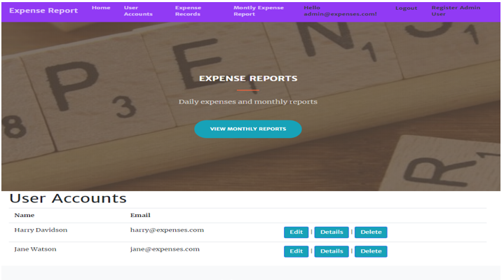

### Monthly Expense Reports Admin View

With the help of this page admin can manage the monthly expense reports such as edit, delete, and access details.

### User Signup Page

With the help of this page new users can register with the application for free.

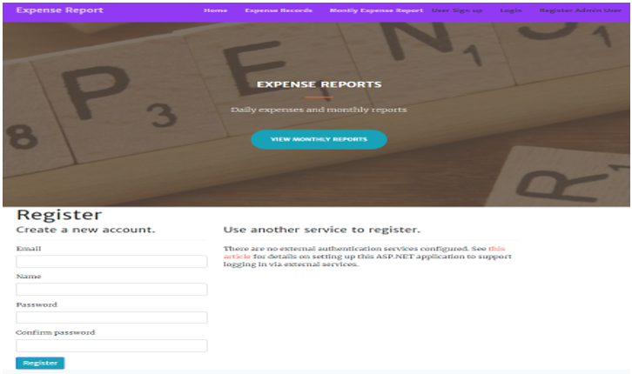

### Expense Records User View

With the help of this page users can create, edit, delete, and check details of expense records.

### Monthly Expense User View

With the help of this page, the user can manage their monthly expenses in terms of generating monthly reports, edit, delete, and check details.

## Project Testing

The testing file for usability testing is attached as [usability test.xlsx](usability%20test.xlsx)

# User Manual

“Daily Expenses Report” project is an online web-based application designed to help the user to manage their daily expenses easily and effectively. In this web application there are two types of user’s admin and normal users. Admin can create, edit, delete, and check details of the expense’s records. Admin also has the right to edit, delete, and check details of the user accounts and monthly expense reports. Normal users can create, edit, delete, and access details of the expense records. Also, can generate monthly expense reports, edit, delete, and access the details. New Users can sign up for the application for free. The current user can manage their accounts. Admin can add new admins to the web application and can manage admin accounts.

## Summary

### System Configuration

This app will be useful to manage daily expenses.

### User Access Levels

Only registered users can access the features of this application.

* **Admin:** Admin has full access to the app can register new admins.
* **Users:**  New customers can register and existing can login using their credentials. They have limited access.